**Insert School Logo**

**Semester Two Examination 2018**

**Question/Answer Booklet**

**MATHEMATICS**

**METHODS UNITS 1 & 2**

**Section Two:**

**Calculator-assumed**

Student Name: _____________________________________

Teacher’s Name: _____________________________________

**Time allowed for this section**

Reading time before commencing work: ten minutes

Working time for paper: one hundred minutes

**Material required/recommended for this section**

**To be provided by the supervisor**

This Question/Answer booklet

Formula Sheet (retained from Section One)

**To be provided by the candidate**

Standard items: pens(blue/black preferred), pencils(including coloured), sharpener, correction tape/fluid, erasers, ruler, highlighters

Special Items: drawing instruments, templates, notes on two unfolded sheets of A4 paper, and up to three calculators approved for use in the WACE examinations.

**Important note to candidates**

No other items may be taken into the examination room. It is **your** responsibility to ensure that you do not have any unauthorised notes or other items of a non-personal nature in the examination room. If you have any unauthorised material with you, hand it to the supervisor **before** reading any further.

**Structure of this paper**

|  |  |  |  |  |  |
| --- | --- | --- | --- | --- | --- |
|  | Number of questions available | Number of questions to be attempted | Suggested working time (minutes) | Marks available | % |
| Section One  Calculator—free | 10 | 10 | 50 | 51 | 35 |
| **Section Two**  **Calculator—assumed** | **16** | **16** | **100** | **99** | **65** |
|  | | | | 150 | 100 |

**Instructions to candidates**

1. The rules for the conduct of Western Australian external examinations are detailed in the *Year 12 Information Handbook 2018.* Sitting this examination implies that you agree to abide by these rules.
2. Answer the questions according to the following instructions.

Section Two: Write answers in this Question/Answer Booklet. Answer **all** questions.

**Show all your working clearly.** Your working should be in sufficient detail to allow your

answers to be checked readily and for marks to be awarded for reasoning. Incorrect

answers given without supporting reasoning cannot be allocated any marks. For any

question or part question worth more than two marks, valid working or justification is required to receive full marks. If you repeat an answer to any question, ensure that you cancel the answer you do not wish to have marked.

It is recommended that you **do not use pencil**, except in diagrams.

1. You must be careful to confine your responses to the specific questions asked and to follow any instructions that are specific to a particular question.
2. Spare pages are included at the end of this booklet. They can be used for planning your responses and/or as additional space if required to continue an answer.

* Planning: If you use the spare pages for planning, indicate this clearly at the top of the page.
* Continuing an answer: If you need to use the space to continue an answer, indicate in the original answer space where the answer is continued, i.e. give the page number. Fill in the number of the question that you are continuing to answer at the top of the page.

1. The Formula Sheet is **not** handed in with your Question/Answer Booklet.

# Section Two: Calculator–assumed 65% (99 marks)

This section has **sixteen (16)** questions. Attempt **all** questions. Write your answers in the spaces provided.

Spare pages are included at the end of this booklet. They can be used for planning your responses and/or as additional space if required to continue an answer.

* Planning: If you use the spare pages for planning, indicate this clearly at the top of the page.
* Continuing an answer: If you need to use the space to continue an answer, indicate in the

original answer space where the answer is continued, i.e. give the page number. Fill in the

number of the question(s) that you are continuing to answer at the top of the page.

Working time: 100 minutes

**Question 11 (6 marks)**

Sarah is a repair technician for a phone company. Each week, she receives a batch of phones that need repairs. The number of phones that she has left to fix at the end of each day can be estimated with the equation *P* = 108 − 23*d*, where *P* is the number of phones left and *d* is the number of days she has worked that week.

**(a)** What is the meaning of the value 108 in this equation? (1 mark)

**(b)** Show that if she starts work on a Monday morning, she would have fixed 92 phones

by Thursday evening. (1 mark)

**(c)** Sarah works an 8-hour day. How long does she work (in hours and minutes) on

Friday to complete the repairs of the batch? (2 marks)

With experience, Sarah works faster. During a busy week she is given a batch of 180 phones to repair. On the Monday she fixes 25 phones, on the Tuesday she fixes 27 phones, on the Wednesday 29 phones and so on.

**(d)** Write a recursive formula to show the number of phones that she has left to fix at the end of each day this week. Let T0 = 180. (2 marks)

**Question 12 (6 marks)**

The point 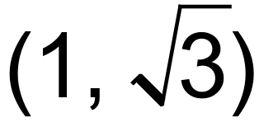 lies on a circle with centre at the origin, O. A tangent to the circle is drawn at A and this intersects with the x-axis at B. Angle AOB = 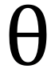.

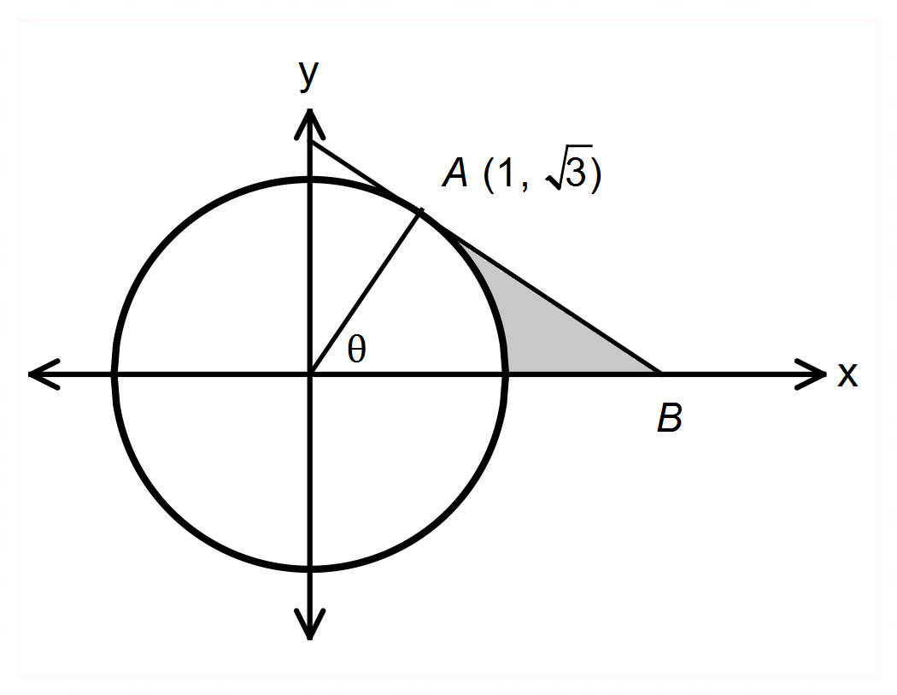

**(a)** State the equation of the circle. (1 mark)

**(b)** Calculate  in radians and the length of the radius of the circle. (2 marks)

**(c)** Hence, calculate the area, to 3 significant figures, indicated by the shaded region.

(3 marks)

**Question 13 (5 marks)**

The equation, 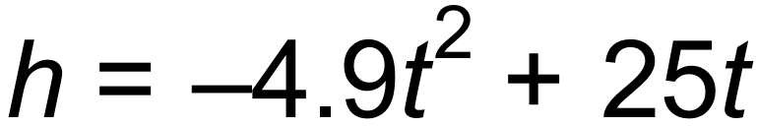, expresses the approximate height *h*, in metres, of a toy rocket *t* seconds after it is launched vertically upward from the ground with an initial velocity of 25 metres per second.

**(a)** After approximately how many seconds will the ball hit the ground? (1 mark)

**(b)** Use derivatives to show that the initial velocity is 25 m/s. (2 marks)

**(c)** State the average speed of the rocket over its time in the air. (2 marks)

**Question 14 (7 marks)**

**(a)** State the function and hence or otherwise evaluate the limit:

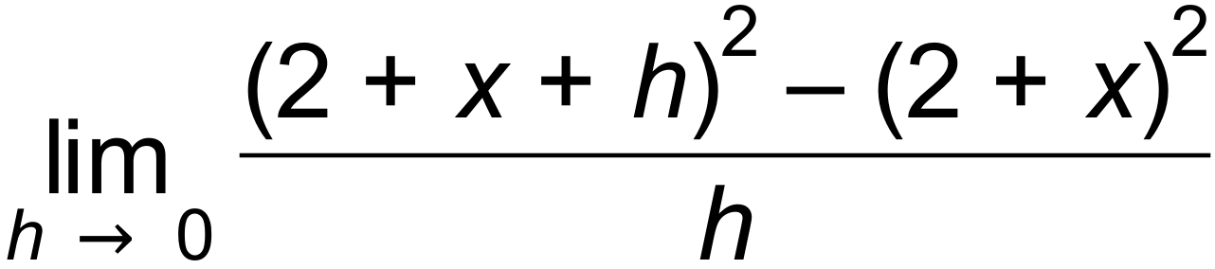 (2 marks)

**(b)** (i) State the instantaneous rate of change of Q with respect to t when t = 4 given that 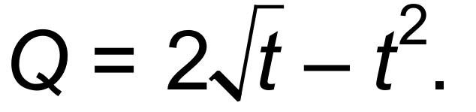 (1 mark)

(ii) State the 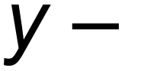intercept of the tangent to Q at 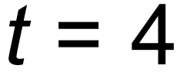. (1 mark)

**(c)** The turning point P(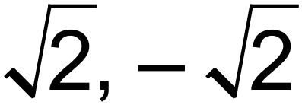) is on the function 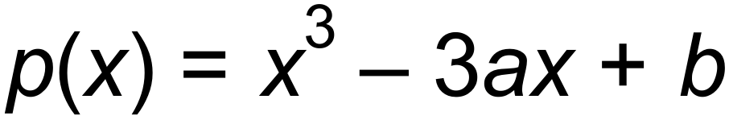. Find the exact values of

a and b. (3 marks)

**Question 15 (10 marks)**

At the point (x, y) where 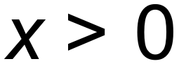, the gradient of a curve is given by 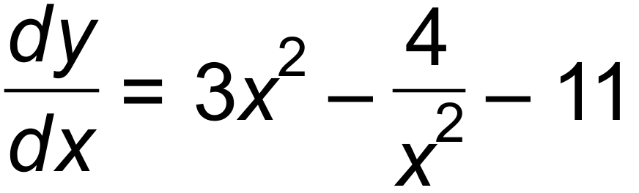.

**(a)** Determine the stationary point(s) of the curve. (2 marks)

**(b)** Find the nature of the stationary point(s) using a sign table. (3 marks)

**(c)** Given that the point (2, 1) is a point on the curve, find the equation of the curve. (2 marks)

**(d)** Sketch the curve on the axes below clearly showing the turning points and the asymptote(s).

(3 marks)

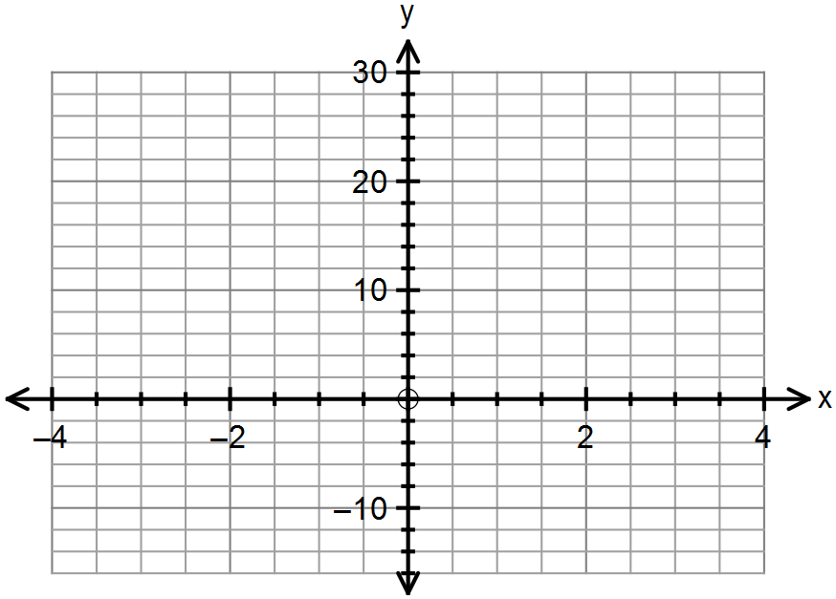

**Question 16 (8 marks)**

**(a)** The arithmetic series 23 + 32 + 41 + 50 +….+ 2534 has a sum of 357 980.

(i) Find the 100th term in the series. (2 marks)

(ii) Find the number of terms in the series? (2 marks)

**(b)** The nth term of a geometric sequence is Tn, where Tn = 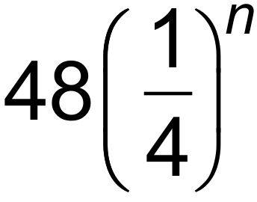.

(i) Determine the recursive rule for the sequence. (2 marks)

(ii) Find the sum to infinity of the series. (2 marks)

**Question 17 (6 marks)**

Reyansh is served a cup of tea at a restaurant. The temperature (T) in °C, of the tea as it cools over time (t) in minutes, can be modelled by the function 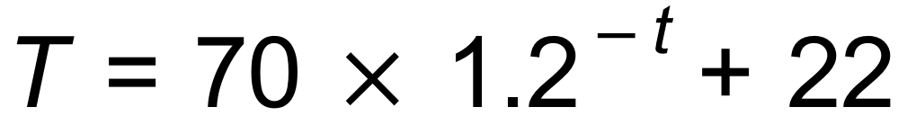

**(a)** State the initial temperature of the tea and the room temperature. (2 marks)

**(b)** Reyansh can drink his tea when the temperature reaches 55°C but will not drink the tea if the temperature drops below 40°C. Determine the time interval when he can drink his tea.

(2 marks)

**(c)** State the horizontal asymptote of the function and explain its significance in this context.

(2 marks)

**Question 18 (6 marks)**

Determine the equations for the following functions.

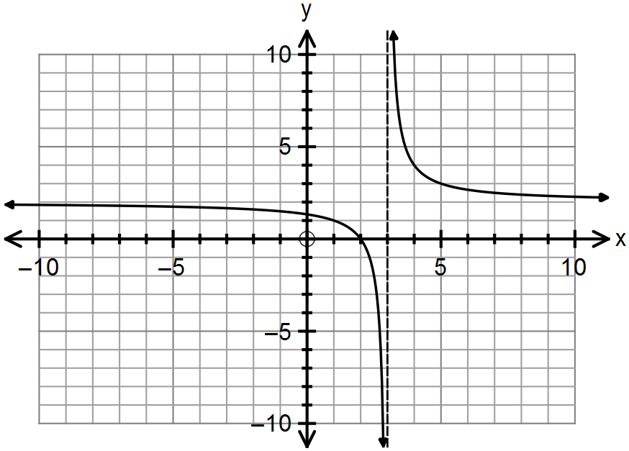**(a)** (2 marks)

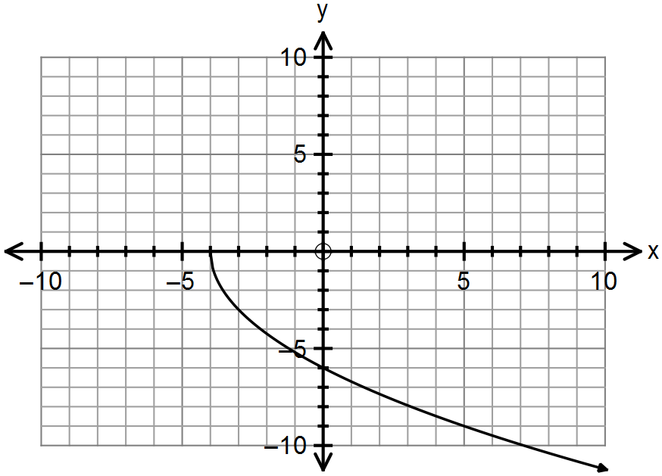**(b)** (2 marks)

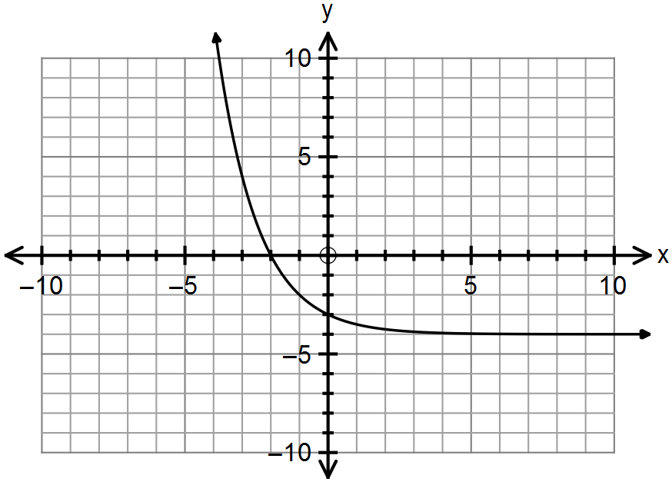**(c)**  (2 marks)

**Question 19 (6 marks)**

For a certain experiment it was found that Pr(X)= 0.5 and Pr(X  Y) = 0.8.

**(a)** State the value of Pr(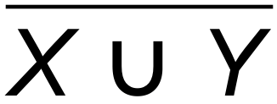). (1 mark)

**(b)** State the maximum possible value of Pr(X  Y). (1 mark)

**(c)** State the minimum possible value of Pr(Y). (1 mark)

**(d)** Determine the value of Pr(Y) if X and Y are independent? (3 marks)

**Question 20 (3 marks)**

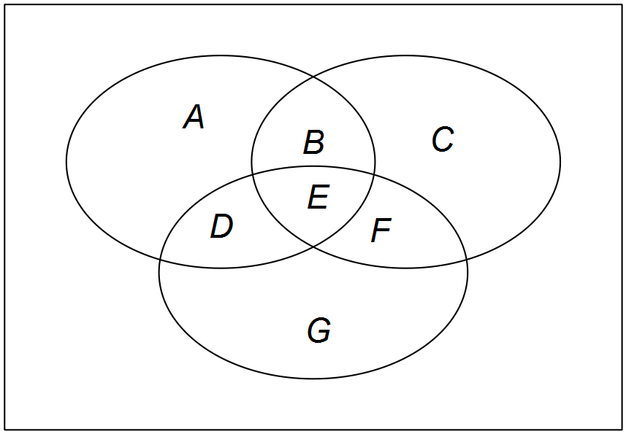Venn diagrams are useful to represent intersecting sets. The number of regions they form with each other creates a numerical pattern.

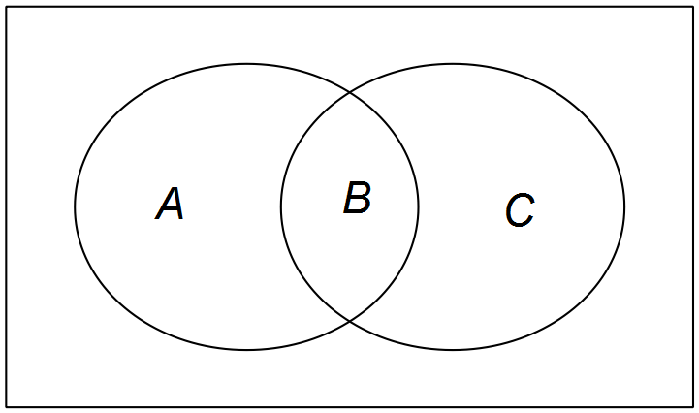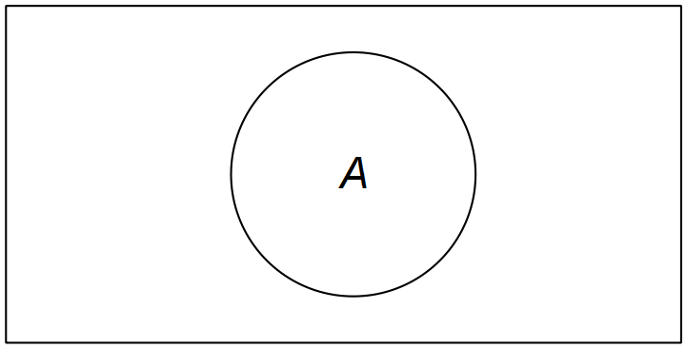



For one set, there is one internal region. For two sets, there are three internal regions.

For three sets there are 7 internal regions. For 4 sets there are 15 internal regions.

**(a)** Write the recursive rule that will generate the number of internal regions with the

addition of each new set. (2 marks)

**(b)** Determine the minimum number of sets to have at least one million internal regions.

(1 mark)

**Question 21 (12 marks)**

The triangle shown below has WY = 6 units, XY = w and WX = y.

The perimeter of triangle WXY is 16 units.

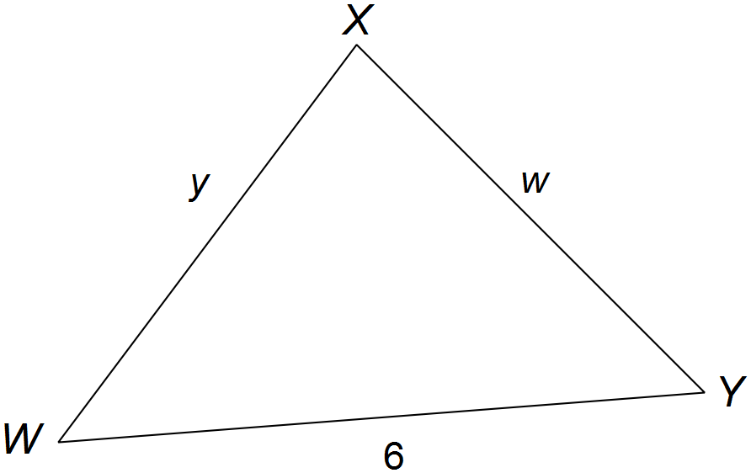

**(a)** (i) Express y in terms of w. (1 mark)

(ii) Use the cosine rule to express 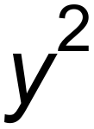 in terms of w and cos Y. (1 mark)

(iii) Hence, show that 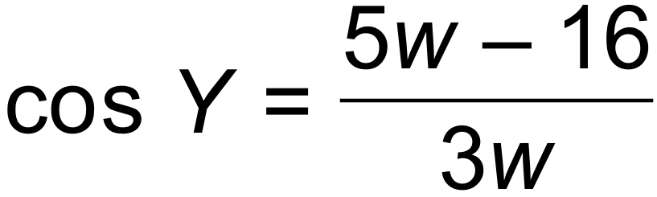. (2 marks)

Let the area of triangle WXY = A.

**(b)** (i) Show that 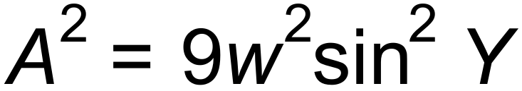. (2 marks)

(ii) Hence show that 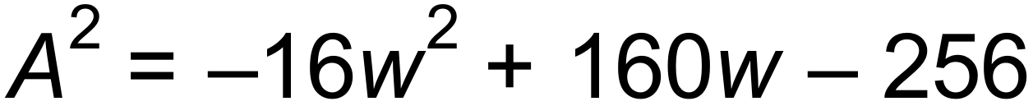 (3 marks)

Hint: Use the identity 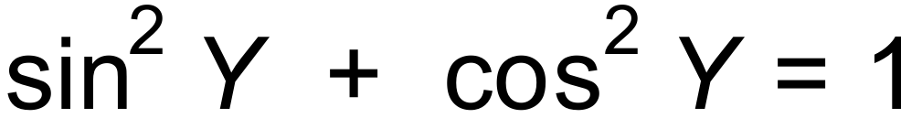

**(c)** (i) Use your calculator to find the maximum area for triangle WXY. (2 marks)

(ii) State what type of triangle this is, when the maximum area is achieved. (1 mark)

**Question 22 (3 marks)**

Given that the graph of 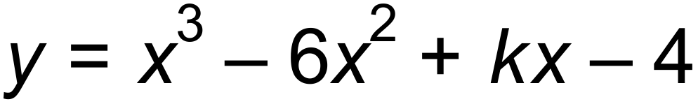 has exactly one point at which the gradient is zero,

find the value of k. (3 marks)

**Question 23 (5 marks)**

There are approximately ten times as many rabbits as wallabies in a certain area. Environmental scientists release a virus which causes the population of rabbits to decrease at a rate of 5% per year.

At the same time the population of wallabies increases at a rate of 8.5% per year.

**(a)** After how many years will there be more wallabies than rabbits? (3 marks)

**(b)** If the initial population of wallabies was estimated at 655, write a recursive rule for

the growth in their population and state the size of the population after 5 years. (2 marks)

**Question 24 (7 marks)**

**(a)** The first two terms of a geometric progression are 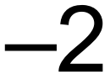 and 3 respectively.

Determine the smallest number of terms which will yield a sum larger than 30. (3 marks)

**(b)** The sum of the 5th and the 7th term of an Arithmetic series is 38. The sum of the

first 15 terms is 375. Determine the sum of the next 15 terms. (4 marks)

**Question 25 (7 marks)**

53% of seventeen year olds who do their driver’s licence test are male. 49% of males pass

on the first attempt, while 58% of females pass on their first attempt.

**(a)** Complete the Venn diagram below to represent the data. (3 marks)

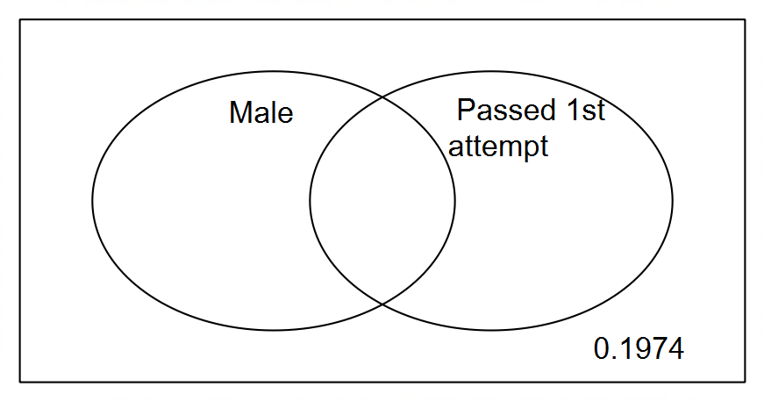

**(b)** Find the probability that a randomly chosen seventeen year old who has taken a

driver’s licence test:

(i) passed on the first attempt. (1 mark)

(ii) is female and passed on the first attempt. (1 mark)

(iii) failed on the first attempt, given that he is male. (1 mark)

(iv) passed on the first attempt or is male. (1 mark)

**Question 26 (2 marks)**

A particle moves in a straight line so that s metres, its displacement from the origin, O,

at time t seconds is given by 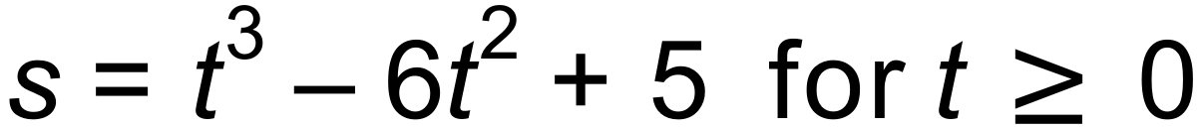.

State its initial position and velocity. (2 marks)

**End of Questions**

**Additional working space**

Question number(s): ……………………

**Additional working space**

Question number(s): ……………………